
EPHRAIM MOGALE

LOCAL MUNICIPALITY

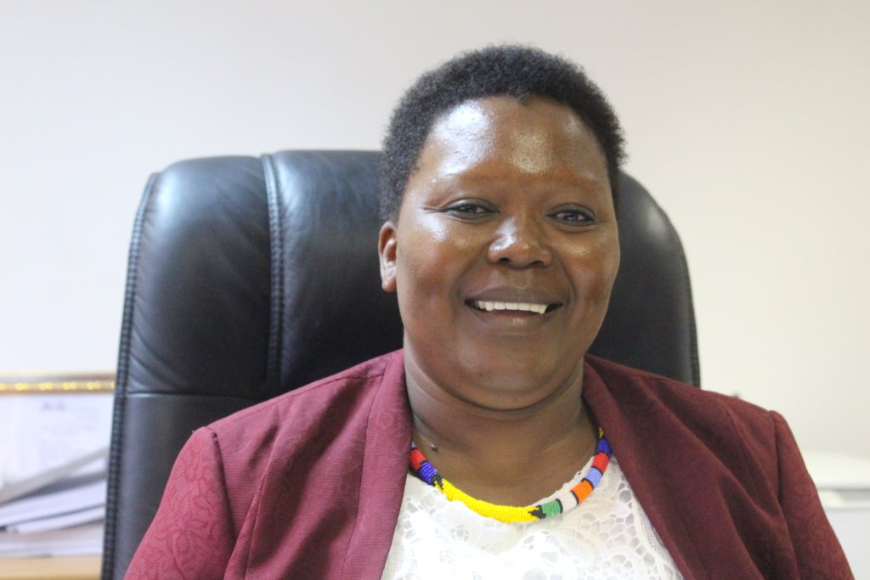 IDP CONSULTATION PROGRAM 2017/18
WARDS | VENUE | DATE | TIME | PRESENTERS
14,15 & 16 | PHETWANE SPORTS GROUND | 04 April 2017 | 10h00 | EXCO & All Cllrs
11,12 & 13 | MOOMANE COMMUNITY HALL | 05 April 2017 | 10h00 | EXCO & All Cllrs
7,8,9 & 10 | LEEUWFONTEIN COMMUNITY HALL | 06 April 2017 | 10h00 | EXCO & All Cllrs
1,2,3,4,5 & 6 | KLOPPER COMMUNITY HALL | 07 April 2017 | 10h00 | EXCO & All Cllrs
Municipal chamber | BUSINESS SECTOR | 11 April 2017 | 10h00 | EXCO & All Cllrs
Caucus | SPECIAL PROGRAM | 12 April 2017 | 10h00 | EXCO & All Cllrs
Municipal Chamber | STAFF | 13 April 2017 | 10h00 | EXCO & All Cllrs

